**IMPACT Task 1**

**Objective:**

To develop an about me website using only HTML and CSS.

**Mandatory Requirements:**

1. Website may contain web-pages defined in LMS
2. Bootstrap is not recommended
3. Website is expected to be responsive
4. Semantic rules of HTML and CSS is expected to be followed

**SDLC Mapping**

|  |  |  |  |  |  |  |  |
| --- | --- | --- | --- | --- | --- | --- | --- |
| **Stage** | **Requirement Analysis & Planning** | **Requirements Definition** | **Architecture** | **Development** | **Testing** | **Deployment** | **Maintenance & support** |
| **Brief Description** | Performed by senior members of a team. Inputs from customer, SMEs, sales department, market surveys etc are taken into account | Requirements are clearly defined and documented. | Best architecture is proposed. | Building the product following code guidelines. | Ensure the product reaches quality defined in SRS. | Release product either to target audience or set of people for UAT. | Enhancements, upgrades, bug fixes, security patches etc. |
| **Output from each stage** | Evaluation of technical feasibility, understanding of potential risks and Determining Quality standards for end-product. | Software Requirement Specification (SRS) document.  Customer approves the document | A design document specification is created. The budget, time constraints, resources, infrastructure required are also determined. | Build modules for the website. | Quality Assured  Product ready for deployment or UAT | Go-live/ feedback after UAT | Updates, enhancements |
| **What I did** | Task to develop an “About me” website was given | Requirements were specified in LMS | Developed wireframes using MockFlow & Draw.io. PDF has been attached separately | Front-end using HTML & CSS. IDE- Visual Studio Code | Tested website using Lighthouse  (Report screenshots attached below) | Hosted website in IIS | N/A |

**Quality Assurance**

|  |  |  |
| --- | --- | --- |
| **Term** | **Description** | **What I did** |
| **Test Strategy** | Identifying what levels of testing are to be applied and the methods, techniques and tools to be used. A test plan states what the items to be tested are, at what level they will be tested, what sequence they are to be tested in, how the test strategy will be applied to the testing of each item and describes the test environment. | N/A |
| **Test case specification.** | The test cases may be documented with the test plan, as a section of a software specification, or in a separate document called a test specification or test description. Test parameter and passing criteria is determined | To ensure smooth navigation, each webpage was navigated from all other pages.  Website was tested to evaluate its responsiveness  Website performance was tested using Lighthouse |
| **Document of User Acceptance Report.** | Website to be evaluated by Mentors and other stakeholders under IMPACT |  |

**Reports from Lighthouse**

**About Page**

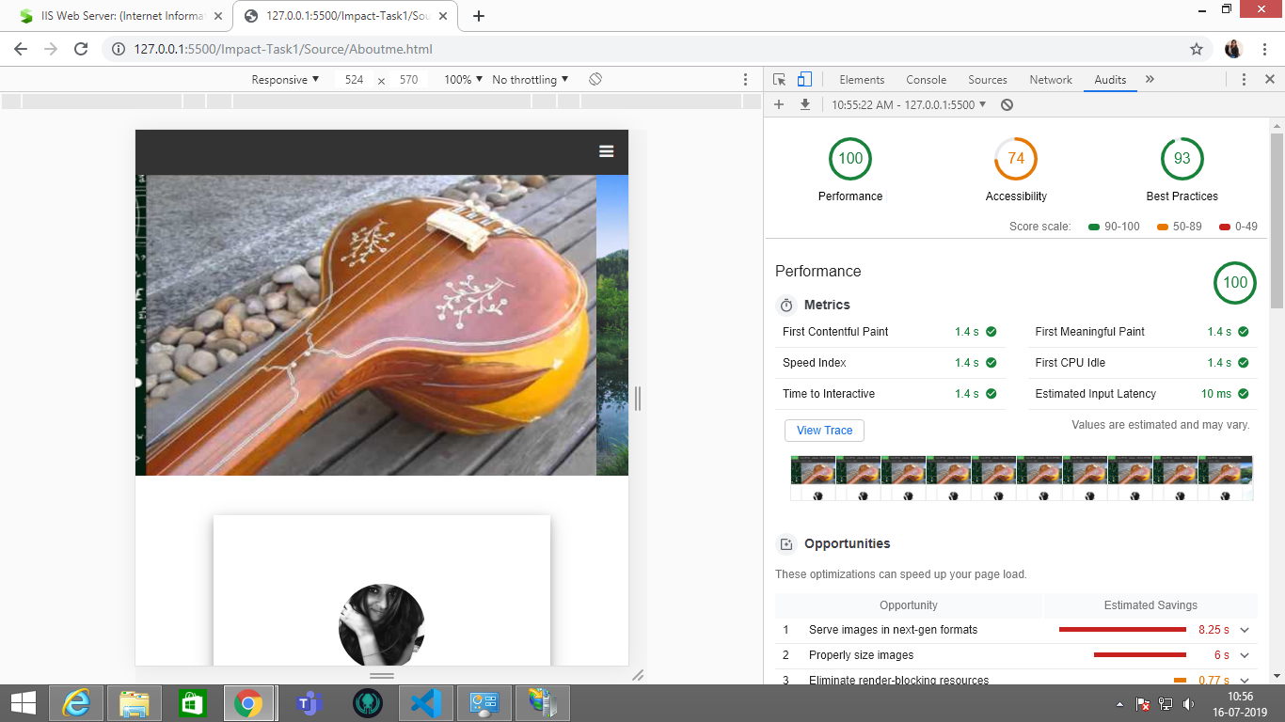

**Personal Information page**

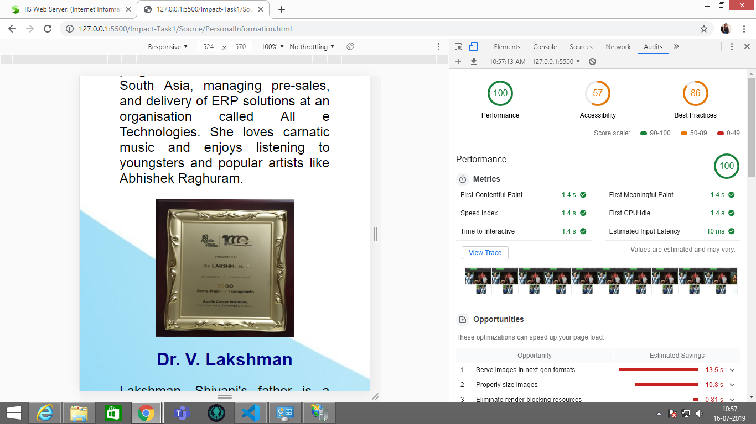

**Academics page**

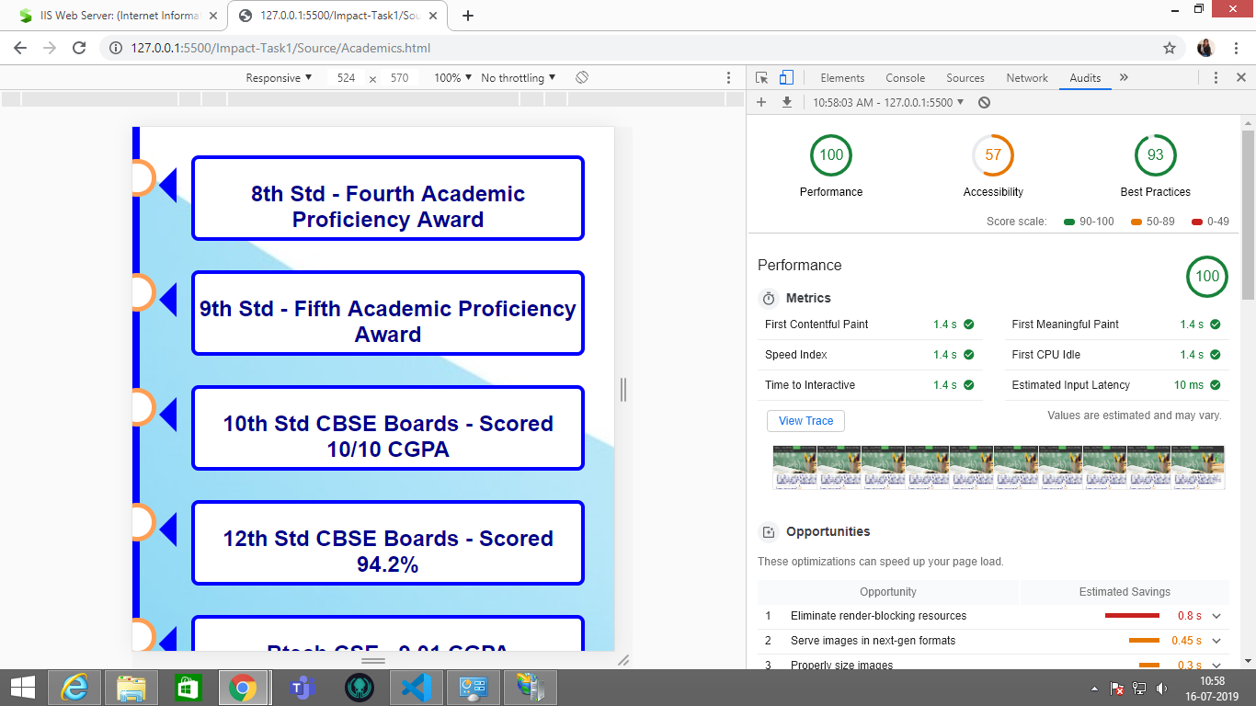

**Professional Achievements page**

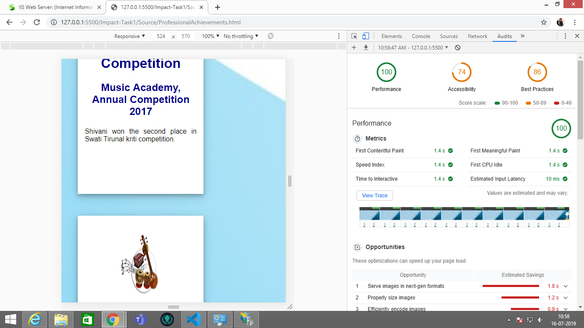

**Extra-curricular page**

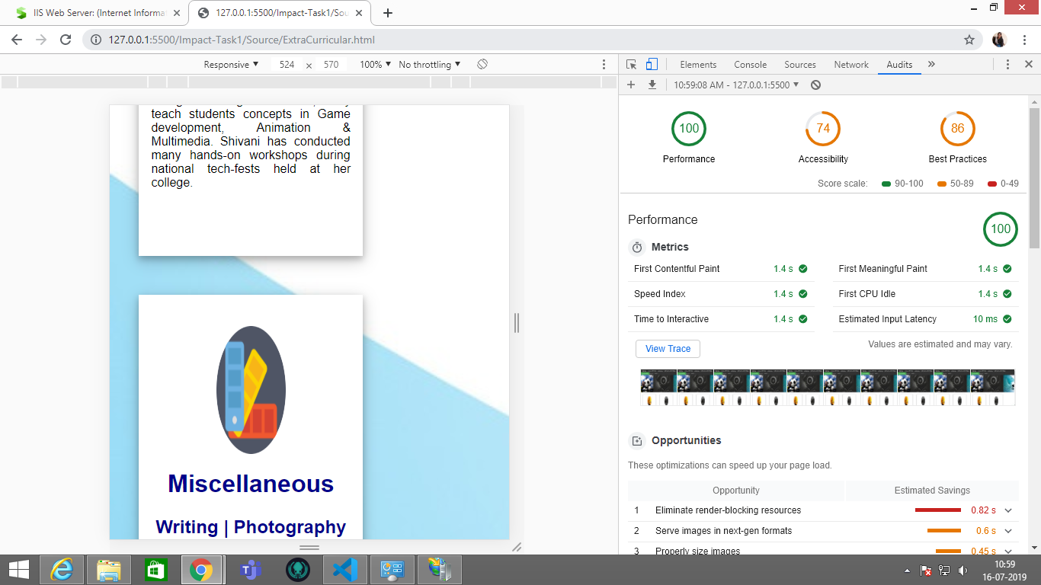

**Gallery page**

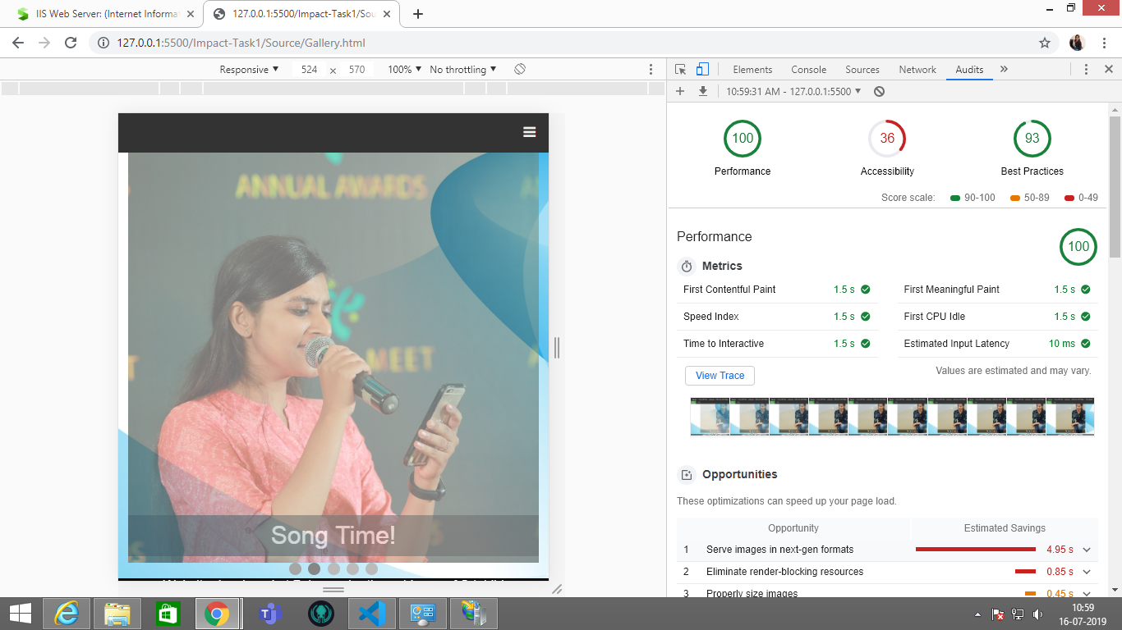

**Contact Page**

